**DAILY ONLINE ACTIVITIES SUMMARY**

|  |  |  |  |  |  |  |  |  |
| --- | --- | --- | --- | --- | --- | --- | --- | --- |
| **Date:** | **01/07/2020** | | | | | **Name:** | **NAIPUNYA VINOD NAIK** | |
| **Sem & Sec** | **IV SEM & A SECTION** | | | | | **USN:** | **4AL18CS050** | |
| **Online Test Summary** | | | | | | | | |
| **Subject** | | **NO INTERNALS CONDUCTED** | | | | | | |
| **Max. Marks** | | **------------** | | **Score** | | | **------------** | |
| **Certification Course Summary** | | | | | | | | |
| **Course** | 1. **LINUX FOR ABSOLUTE BEGINNERS** 2. **WEBINAR FOR IOT** | | | | | | | |
| **Certificate Provider** | | | **1)UDEMY**  **2) GIRLSCRIPT UDUPI** | | **Duration** | | | **1)7 HRS**  **2) 1 HR** |
| **Coding Challenges** | | | | | | | | |
| **Problem Statement: 1)** [Given two lists, sort the values of one list using the second list](https://github.com/orgs/alvas-education-foundation/teams/2nd-year/discussions/143). | | | | | | | | |
| **Status: EXECUTED** | | | | | | | | |
| **Uploaded the report in Github** | | | | | **YES** | | | |
| **If yes Repository name** | | | | | <https://github.com/naipunya-naik/lockdown-coding/blob/master/PYTHON%20CODING/sort_01-07-2020.py> | | | |
| **Uploaded the report in slack** | | | | | **YES** | | | |

Online Test Details: (Attach the snapshot and briefly write the report for the same)

NO INTERNALS CONDUCTED

Certification Course Details: (Attach the snapshot and briefly write the report for the same).

CERTIFICATION COURSE NAME:- LINUX FOR ABSOLUTE BEGINNERS



TOPICS LEARNT TODAY ON 01 JULY 2020:-

* Linux installation
* Command line usage
* Development tools including choosing an IDE
* GitHub setup
* Complete Meteor.js web project

1. WEBINAR ON IOT

* CONDUCTED BY :- MR BHUVAN,IOT ENTHUSIAST,ECE DEPT,NMAMIT
* DURATION:- 1 HR
* 
* 

TOPICS COVERED IN WEBINAR

* INTRODUCTION
* CONNECTED TO DEVICES
* INTERNET OF THINGS
* HOW TO GET STORED? (NODEMCU,ARDUINO,RASPBERRY PI)
* DO IT YOURSELF
* HOW DO I START RIGHT NOW?
* IOT & CLOUD
* MACHINE LEARNING AND IOT

Coding Challenges Details: (Attach the snapshot and briefly write the report for the same).

PROBLEM STATEMENT:- [Given two lists, sort the values of one list using the second list](https://github.com/orgs/alvas-education-foundation/teams/2nd-year/discussions/143).

Top of Form

Bottom of Form

|  |
| --- |
| Examples: Input : list1 = ["a", "b", "c", "d", "e", "f", "g", "h", "i"] list2 = [ 0, 1, 1, 0, 1, 2, 2, 0, 1] Output : ['a', 'd', 'h', 'b', 'c', 'e', 'i', 'f', 'g'] Input : list1 = ["g", "e", "e", "k", "s", "f", "o", "r", "g", "e", "e", "k", "s"] list2 = [ 0, 1, 1, 0, 1, 2, 2, 0, 1] Output : ['g', 'k', 'r', 'e', 'e', 'g', 's', 'f', 'o'] |

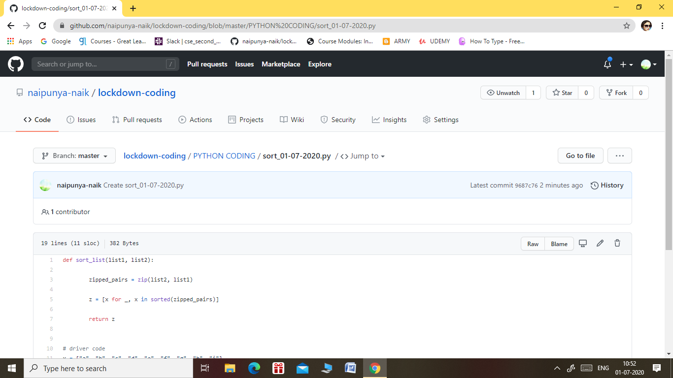

GITHUB REPOSITORY LINK:-

<https://github.com/naipunya-naik/lockdown-coding/blob/master/PYTHON%20CODING/sort_01-07-2020.py>